

**Assistive Reality**Initial coin offering instructions/guidance  
**ARX** token  
Extract from [v14r-public Whitepaper download](https://github.com/assistivereality/ico/raw/master/whitepaper/Assistive%20Reality%20aronline.io%20Whitepaper%20and%20Ethereum%20ICO%20instructions%20September%202017%20(v14%20release-Public).docx)

## Crowdsale / ICO instructions

A number wallets are compatible with this **ARX** Ethereum token ICO (**ARX** being an ERC20 token), such as:

* MyEtherWallet (no download needed) <https://www.myetherwallet.com/>
* MetaMask (Firefox and Chrome browser add-on) <https://metamask.io/>
* Mist (Desktop) <https://github.com/ethereum/mist/releases>
* Parity (Desktop) <https://ethcore.io/parity.html>
* imToken (iPhone) <https://itunes.apple.com/us/app/imtoken/id1153230571?ls=1&mt=8>
* imToken (Android) <https://token.im/>

Contact us at [staff@aronline.io](mailto:staff@aronline.io) for more information about a specific wallet or query. It is important to consider that potential network congestion can cause temporarily higher fee requirements for the transactions. Our ICO is fully tested with Mist which successfully predicts the correct gas values; we also have some comments below around the gas values you may need to expect for operation of our ICO contract.

The screenshots and instructions below will guide you through a few methods of participating in the Crowdsale, including configuring your Mist browser to ‘watch’ the Assistive Reality **ARX** token, and to send an **Ether** donation to the Crowdsale, and how to verify you have received your **ARX** tokens in return. The ARX tokens should be retained in your personal wallet until such time as you redeem them using our redemption smart contracts for aronline.io services or apps.

The ICO parameters, **address** and **JSON** interface definition are below:

|  |  |
| --- | --- |
| **Assistive Reality** ARX token offering on Ethereum public blockchain | |
| ICO Token, Symbol, Name | **ARX** |
| ICO Contract Address on Mainnet | **0xAeDe31213C15D2273C1871e716fC8E762D176564** |
| **Start** date/time (approx.) | **26 September 7:00PM GMT** |
| Start block | **4296250** |
| **End** date/time (approx.) | 17 October 7:00PM GMT |
| End block | 4395756 |
| ETH softcap funding level | 7,000 |
| ETH hardcap funding level | 70,000 |
| Type of sale | Dynamic (tokens are created & sent live, up to the cap) |
| Price | Static 4,000 tokens per ETH (0.00025) |
| Total token cap | 308,000,000 |
| Refund available if unsuccessful | Yes, by calling Refund() function in ICO contract |
| Security Reviewed | Yes (numerous) |
| Halt protect | Yes |
| Source code | <https://github.com/assistivereality> |
| JSON definition | Click here to get the raw JSON for copy/paste <https://raw.githubusercontent.com/assistivereality/ico/master/jsonforICO.txt> or see Appendix A: JSON |
| Information URL | <https://aronline.io/icoinfo> |

**Participating:**

To participate in our ICO after the Start Block **4296250**, which should occur on the Ethereum main net Blockchain around 26 September 7:00PM GMT (though when the block occurs can vary slightly) you have a few options, such as:

1. Use any of the wallets below to send **ETH** to the ICO contract address **0xAeDe31213C15D2273C1871e716fC8E762D176564**

You will receive your tokens in return immediately. Mist recommends around 76,000 gas for the transaction on mainnet and has no problem with the transaction by default however during the ICO period fee contention can occur; if you experience issues, try a higher fee.

MyEtherWallet (no download needed) <https://www.myetherwallet.com/>  
MetaMask (Firefox and Chrome browser add-on) <https://metamask.io/>  
Mist (Desktop) <https://github.com/ethereum/mist/releases>  
Parity (Desktop) <https://ethcore.io/parity.html>  
imToken (iPhone) <https://itunes.apple.com/us/app/imtoken/id1153230571?ls=1&mt=8>  
imToken (Android) <https://token.im/>

1. Or, Use the Mist browser on a Synchronised Node to send ETH to the ICO contract address. You will receive your tokens immediately in a return transaction. You should also select ‘Contracts’, ‘Watch token’, then copy/paste the ICO contract address into the address field, and click OK once the browser fills in the remainder of the form with the ARX token information. This will enable you to see your tokens. See later in this section for screenshots.

**0xAeDe31213C15D2273C1871e716fC8E762D176564**

1. Or, Use the Mist browser (or alternative) to execute the **BuyTokens** function in the Crowdsale contract, which looks like this and will send you tokens in return for your ETH. This function requires a very small amount of additional gas compared to sending ETH to the ICO address directly. Mist recommends around 76,000 by default though this can vary.

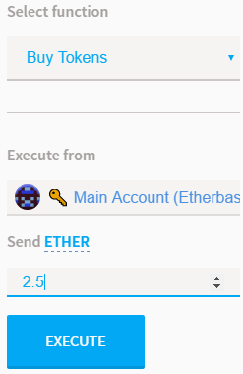

To do this, for example within the Mist browser, you would need to select ‘Contracts’ then ‘Watch contract’, then Copy/Paste the ICO token address into the address field:

1. Click contracts, scroll down to Custom Contracts, and click Watch Contract:

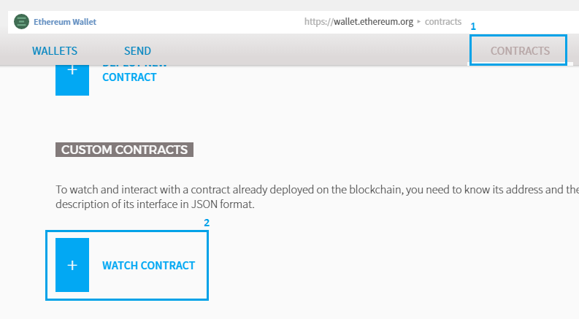

1. Paste in the contract address **0xAeDe31213C15D2273C1871e716fC8E762D176564**
2. Enter a name such as **ARX Crowdsale**
3. Paste in the contents of the JSON interface file, from this text file, into the JSON field, also available on GitHub here, or via the Appendix A: JSON.  
   <https://raw.githubusercontent.com/assistivereality/ico/master/jsonforICO.txt>

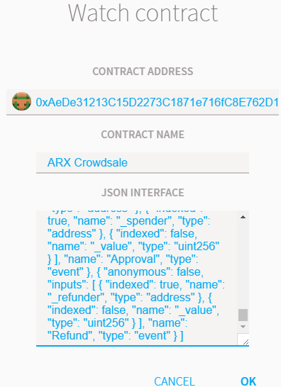

1. Click OK to proceed with watching the contract

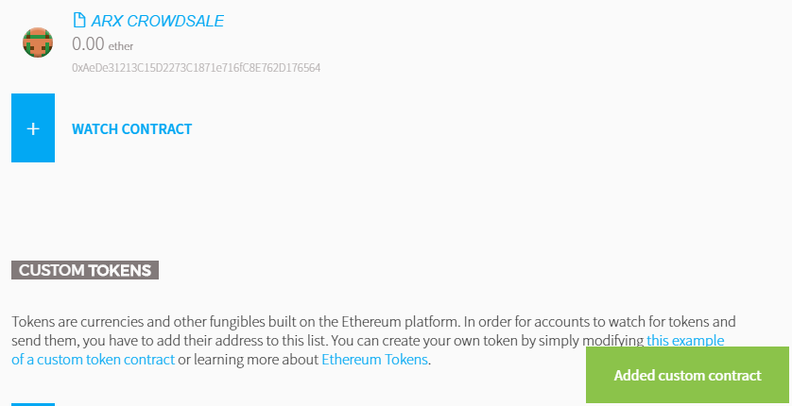

1. Now that you have added the contract to watch, you may also wish to watch the token so you can see when they are transferred to you. In mist, this is achieve by scrolling down the ‘Contracts’ page until you see ‘Custom Tokens’ then clicking ‘Watch Token’

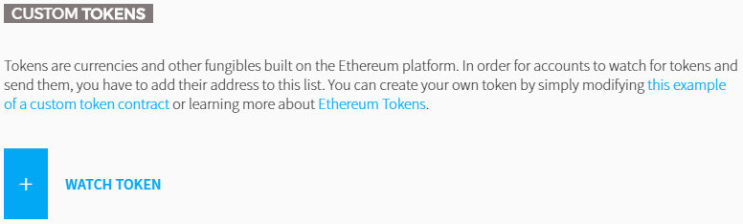

1. In the token watch entry form, paste in the token ICO contract address:

**0xAeDe31213C15D2273C1871e716fC8E762D176564**

1. The remainder of the form will auto-fill if you have entered the address correctly. Confirm you can see the ARX token details such as below, and click OK.

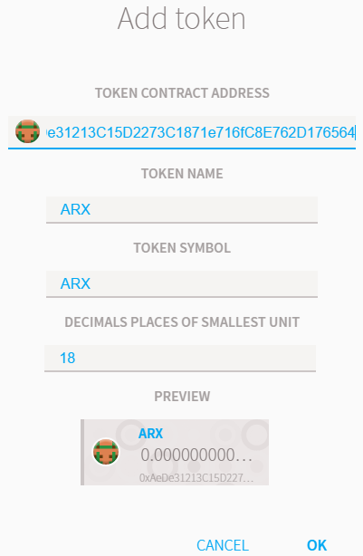

1. Now that you have both the token and contract being watched, you are free to use the functions provided by the Crowdsale contract, and will see the ARX tokens when they arrive into your wallet. Simply click on the Contract ‘**ARX** **Crowdsale’** in the ‘**Contracts’** section of Mist, and scroll down to see the functions, not all of which are available to you:

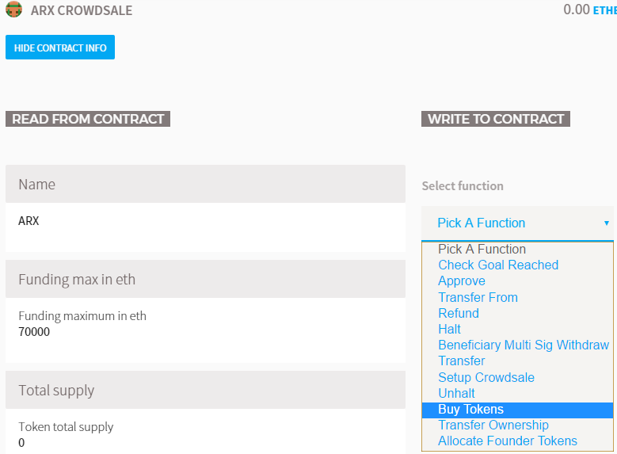

1. Enter the amount you wish to purchase, then click execute, authorise the transfer and you’ll see the exchange ETH/ARX occur and receive your ARX immediately (screenshots are from testnet contract since the ICO will not allow purchases until block 4296250)

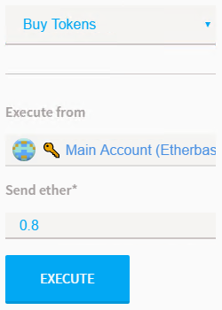

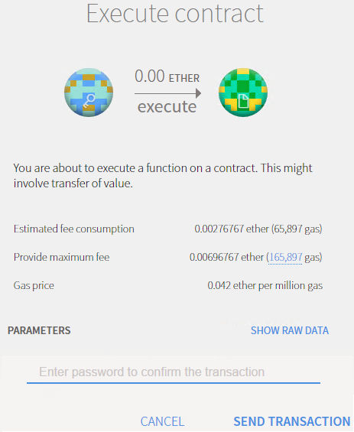

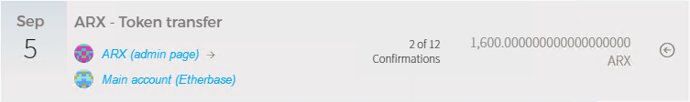

As a general recommendation we have observed that the gas price for interacting with the ICO contract is always fine at the default in Mist therefore a synchronised Mist wallet is usually the best. However any of the common wallets that support (in full) ERC20 tokens can be used. If any fee contention or gas issues are experienced increase your paid fees until your transaction is successfully mined; though we have taken some effort to attempt to minimise the gas cost of the ARX ICO contract.

You can view information about the Crowdsale by watching the contract in Mist, then selecting it under Contracts and scrolling down from the header. Many fields will update live during the Crowdsale, and a few allow interaction during the sale (for example, the ‘approve’ function and the ‘balance of’ fields)

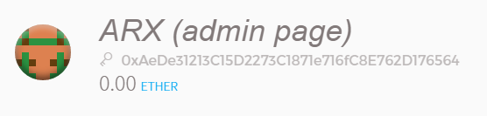



1. If the ICO is unsuccessful in reaching its minimum funding (softcap) level, as soon as the ‘**Funding End Block**’ has passed, users can execute the Refund() function from within the ICO contract to retrieve their ETH. We cannot manually send it back, you must execute Refund() from the account that submitted the ETH. Once submitted you will receive your ETH back immediately, and the ARX tokens will be removed from your balance. You can alternatively elect to retain/keep the ARX token as a souvenir. (Though we do not gain access to the submitted ETH unless the softcap is reached so we would suggest you to issue the Refund()).

Refunds only cost the fee/gas and you will receive 100% of your funds back.

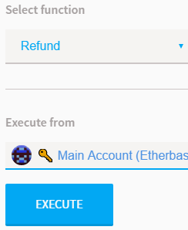

## Legal / disclaimer

By participating in the ARX ICO Token Crowdsale or making use of any information in this whitepaper or available on the aronline.io website, you agree to the following:

**GENERAL WARNING-**By using the services provided by Assistive Reality, you the (User) as either an Initial Coin Offering (hereinafter – ICO or Crowdsale) participant or (User) of Assistive Reality alpha products or services, fully understands and agrees with the following:

* User understands and acknowledges that ARX tokens will be provided by the ICO smart contract in the order that transactions are received by it and no alteration of this can be made by any party
* User understands that Assistive Reality carries no liability for the ability to take part in the ICO for reasons beyond the control of Assistive Reality including but not limited to the ICO duration, transaction mining delays and node-related issues
* Pending a successful ICO, Assistive Reality team members will be focused on completing the company start-up and delivering on milestones. However Assistive Reality undertakes no obligations to act on behalf and in the interests of User in the ICO being held in the future
* User understands that by transferring assets to Assistive Reality, User makes the final decision on deposition of cash or other assets and has no right of refund except that which is provided by the ICO smart contract code itself (that being, a 100% refund when capital raised is under the minimum cap and the ICO / crowdsale period has expired)

**TAX WARNING-**  
User understands that Assistive Reality does not act as a tax agent of User; User and Assistive Reality carry their tax obligations solely under the applicable laws of the country and location they reside in. Assistive Reality is not a tax agent and therefore shall not provide Users' financial information to any third parties. This information shall not be disclosed unless officially requested by government authorities.

**NO WARRANTIES-**All of the information provided within this whitepaper is provided “AS-IS” and with no warranties. No express or implied warranties of any type, including implied warranties of merchantability or fitness for a particular purpose, are made with respect to the information, or any use of the information, on this site or platform. Assistive Reality makes no representations and extends no warranties of any type as to the accuracy or completeness of any information or content in this whitepaper or regarding this platform.

**DISCLAIMER OF LIABILITY-**Assistive Reality specifically disclaims liability for incidental or consequential damages and assumes no responsibility or liability for any loss or damage suffered by any person as a result of the use or misuse of any of the information or content in this whitepaper or on the aronline.io website. Assistive Reality assumes or undertakes no liability for any loss or damage suffered as a result of the use, misuse or reliance on the information and content in this whitepaper or on the aronline.io website.

In no event shall Assistive Reality be liable to User for any special, indirect, incidental, consequential, exemplary or punitive damages (including lost or anticipated revenues or profits and failure to realise expected savings arising from any claim relating to the services provided by Assistive Reality) whether such claim is based on warranty, contract, tort (including negligence or strict liability) or otherwise or likelihood of the same.

**USE AT YOUR OWN RISK-**By using the ICO smart contract for ARX, the Assistive Reality platform or aronline.io website including but not limited to the transferring assets to Assistive Reality, User confirms that he undertakes and understand all the possible risks that directly or indirectly arise from the activity connected with User’s participation in the ICO and/or use of Assistive Reality services and products.

**FORCE-MAJEURE-**User understands that Assistive Reality will not be liable to User for any breach hereunder, including for failure to deliver or delays in delivery of the Services occasioned by causes beyond the control of Assistive Reality including but not limited to unavailability of materials, strikes, labour slowdowns and stoppages, labour shortages, lockouts, fires, floods, earthquakes, storms, droughts, adverse weather, riots, thefts, accidents, embargoes, war (whether or not declared) or other outbreak of hostilities, civil strife, acts of governments, acts of God, governmental acts or regulations, orders or injunctions, or other reasons, whether similar or dissimilar to the foregoing (each a “Force Majeure Event”).

**FINAL WARNING-**ICO participations can be can be considered High-Risk Trading; purchasing financial instruments via an ICO or utilising services offered on the website may result in significant losses or even in a total loss of all funds invested.

* No information provided on Assistive Reality’s platform or website should be interpreted as investment advice. It does not constitute an offer or invitation by Assistive Reality to any User to buy or to sell tokens or make any investment.
* User guarantees that he is a legally capable person of a majority age and complies with legal rules and applicable laws of the jurisdiction where the User lives.
* By participating in the ICO User confirms that he has read, understood and agree to comply with all restrictions set forth above.

#### **Appendix A: JSON definition for ICO**

[ { "constant": false, "inputs": [], "name": "checkGoalReached", "outputs": [ { "name": "response", "type": "bytes32" } ], "payable": false, "type": "function" }, { "constant": true, "inputs": [], "name": "name", "outputs": [ { "name": "", "type": "string", "value": "ARX" } ], "payable": false, "type": "function" }, { "constant": false, "inputs": [ { "name": "_spender", "type": "address" }, { "name": "_amount", "type": "uint256" } ], "name": "approve", "outputs": [ { "name": "success", "type": "bool" } ], "payable": false, "type": "function" }, { "constant": true, "inputs": [], "name": "fundingMaxInEth", "outputs": [ { "name": "fundingMaximumInEth", "type": "uint256", "value": "70000" } ], "payable": false, "type": "function" }, { "constant": true, "inputs": [], "name": "totalSupply", "outputs": [ { "name": "tokenTotalSupply", "type": "uint256", "value": "0" } ], "payable": false, "type": "function" }, { "constant": true, "inputs": [], "name": "tokensPerEthPrice", "outputs": [ { "name": "", "type": "uint256", "value": "4000" } ], "payable": false, "type": "function" }, { "constant": false, "inputs": [ { "name": "_from", "type": "address" }, { "name": "_to", "type": "address" }, { "name": "_amount", "type": "uint256" } ], "name": "transferFrom", "outputs": [ { "name": "success", "type": "bool" } ], "payable": false, "type": "function" }, { "constant": true, "inputs": [], "name": "decimals", "outputs": [ { "name": "", "type": "uint8", "value": "18" } ], "payable": false, "type": "function" }, { "constant": true, "inputs": [], "name": "isCrowdSaleSetup", "outputs": [ { "name": "", "type": "bool", "value": true } ], "payable": false, "type": "function" }, { "constant": true, "inputs": [], "name": "beneficiaryMultiSig", "outputs": [ { "name": "", "type": "address", "value": "0xd93333f8cb765397a5d0d0e0ba53a2899b48511f" } ], "payable": false, "type": "function" }, { "constant": false, "inputs": [], "name": "refund", "outputs": [], "payable": false, "type": "function" }, { "constant": true, "inputs": [], "name": "standard", "outputs": [ { "name": "", "type": "string", "value": "ARX" } ], "payable": false, "type": "function" }, { "constant": true, "inputs": [], "name": "founderTokensAvailable", "outputs": [ { "name": "", "type": "bool", "value": false } ], "payable": false, "type": "function" }, { "constant": false, "inputs": [], "name": "halt", "outputs": [], "payable": false, "type": "function" }, { "constant": true, "inputs": [], "name": "foundationFundMultisig", "outputs": [ { "name": "", "type": "address", "value": "0x70a0be1a5d8a9f39afed536ec7b55d87067371aa" } ], "payable": false, "type": "function" }, { "constant": true, "inputs": [ { "name": "_owner", "type": "address" } ], "name": "balanceOf", "outputs": [ { "name": "balance", "type": "uint256", "value": "0" } ], "payable": false, "type": "function" }, { "constant": true, "inputs": [], "name": "amountRaisedInWei", "outputs": [ { "name": "", "type": "uint256", "value": "0" } ], "payable": false, "type": "function" }, { "constant": false, "inputs": [ { "name": "_amount", "type": "uint256" } ], "name": "beneficiaryMultiSigWithdraw", "outputs": [], "payable": false, "type": "function" }, { "constant": true, "inputs": [], "name": "amountRaisedInEth", "outputs": [ { "name": "amountRaisedSoFarInEth", "type": "uint256", "value": "0" } ], "payable": false, "type": "function" }, { "constant": true, "inputs": [], "name": "owner", "outputs": [ { "name": "", "type": "address", "value": "0x5ed4706a93b8a3239f97f7d2025ce1f9eadcd9a4" } ], "payable": false, "type": "function" }, { "constant": true, "inputs": [], "name": "fundingEndBlock", "outputs": [ { "name": "", "type": "uint256", "value": "4395756" } ], "payable": false, "type": "function" }, { "constant": true, "inputs": [], "name": "remainingCapInEth", "outputs": [ { "name": "remainingHardCapInEth", "type": "uint256", "value": "70000" } ], "payable": false, "type": "function" }, { "constant": true, "inputs": [], "name": "symbol", "outputs": [ { "name": "", "type": "string", "value": "ARX" } ], "payable": false, "type": "function" }, { "constant": true, "inputs": [], "name": "isCrowdSaleFinished", "outputs": [ { "name": "", "type": "bool", "value": false } ], "payable": false, "type": "function" }, { "constant": true, "inputs": [], "name": "fundingMinInEth", "outputs": [ { "name": "fundingMinimumInEth", "type": "uint256", "value": "7000" } ], "payable": false, "type": "function" }, { "constant": false, "inputs": [ { "name": "_to", "type": "address" }, { "name": "_amount", "type": "uint256" } ], "name": "transfer", "outputs": [ { "name": "success", "type": "bool" } ], "payable": false, "type": "function" }, { "constant": false, "inputs": [ { "name": "_fundingStartBlock", "type": "uint256" }, { "name": "_fundingEndBlock", "type": "uint256" } ], "name": "SetupCrowdsale", "outputs": [ { "name": "response", "type": "bytes32" } ], "payable": false, "type": "function" }, { "constant": true, "inputs": [], "name": "fundingMinInWei", "outputs": [ { "name": "", "type": "uint256", "value": "7e+21" } ], "payable": false, "type": "function" }, { "constant": true, "inputs": [], "name": "foundationFundTokenCountInWei", "outputs": [ { "name": "", "type": "uint256", "value": "0" } ], "payable": false, "type": "function" }, { "constant": true, "inputs": [], "name": "halted", "outputs": [ { "name": "", "type": "bool", "value": false } ], "payable": false, "type": "function" }, { "constant": false, "inputs": [], "name": "unhalt", "outputs": [], "payable": false, "type": "function" }, { "constant": true, "inputs": [], "name": "fundingStartBlock", "outputs": [ { "name": "", "type": "uint256", "value": "4316376" } ], "payable": false, "type": "function" }, { "constant": true, "inputs": [], "name": "remainingCapInWei", "outputs": [ { "name": "", "type": "uint256", "value": "7e+22" } ], "payable": false, "type": "function" }, { "constant": false, "inputs": [], "name": "BuyTokens", "outputs": [], "payable": true, "type": "function" }, { "constant": true, "inputs": [ { "name": "_owner", "type": "address" }, { "name": "_spender", "type": "address" } ], "name": "allowance", "outputs": [ { "name": "remaining", "type": "uint256", "value": "0" } ], "payable": false, "type": "function" }, { "constant": true, "inputs": [], "name": "CurrentStatus", "outputs": [ { "name": "", "type": "string", "value": "Crowdsale is setup" } ], "payable": false, "type": "function" }, { "constant": true, "inputs": [], "name": "fundingMaxInWei", "outputs": [ { "name": "", "type": "uint256", "value": "7e+22" } ], "payable": false, "type": "function" }, { "constant": false, "inputs": [ { "name": "newOwner", "type": "address" } ], "name": "transferOwnership", "outputs": [], "payable": false, "type": "function" }, { "constant": true, "inputs": [], "name": "admin", "outputs": [ { "name": "", "type": "address", "value": "0x5ed4706a93b8a3239f97f7d2025ce1f9eadcd9a4" } ], "payable": false, "type": "function" }, { "constant": false, "inputs": [], "name": "AllocateFounderTokens", "outputs": [], "payable": false, "type": "function" }, { "inputs": [], "payable": false, "type": "constructor" }, { "payable": true, "type": "fallback" }, { "anonymous": false, "inputs": [ { "indexed": true, "name": "_sender", "type": "address" }, { "indexed": false, "name": "_eth", "type": "uint256" }, { "indexed": false, "name": "_ARX", "type": "uint256" } ], "name": "Buy", "type": "event" }, { "anonymous": false, "inputs": [ { "indexed": true, "name": "_from", "type": "address" }, { "indexed": true, "name": "_to", "type": "address" }, { "indexed": false, "name": "_value", "type": "uint256" } ], "name": "Transfer", "type": "event" }, { "anonymous": false, "inputs": [ { "indexed": false, "name": "_from", "type": "address" }, { "indexed": false, "name": "_value", "type": "uint256" } ], "name": "Burn", "type": "event" }, { "anonymous": false, "inputs": [ { "indexed": true, "name": "_owner", "type": "address" }, { "indexed": true, "name": "_spender", "type": "address" }, { "indexed": false, "name": "_value", "type": "uint256" } ], "name": "Approval", "type": "event" }, { "anonymous": false, "inputs": [ { "indexed": true, "name": "_refunder", "type": "address" }, { "indexed": false, "name": "_value", "type": "uint256" } ], "name": "Refund", "type": "event" } ]